2017 : GOOGLE

TiE The Indus Entrepreneurs

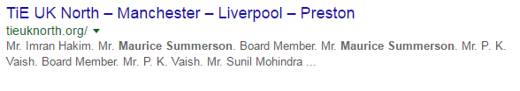
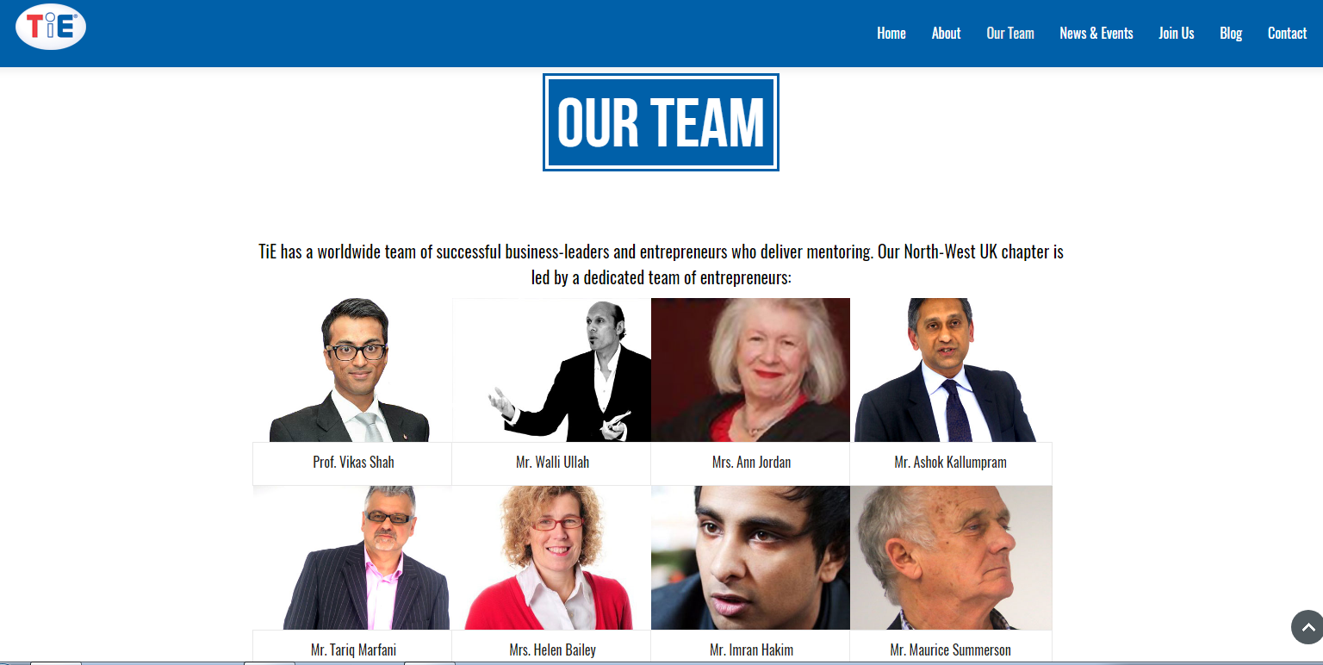
http://tie.org/

##################################################################################

MR MAURICE SUMMERSON director information. Free director ...
companycheck.co.uk/director/911064456/MR-MAURICE-SUMMERSON/summary
Mr Maurice Summerson holds 0 appointments at 0 active companies, has now resigned from 44 companies and held 0 appointments at 0 dissolved companies. ON DATE 17 MAY 2017 AFTER RETIREMENT IN UK.

##################################################################################

Maurice Summerson | Believe | Act | Achieve
www.mauricesummerson.com/
################################################################################

